**Amazon Web Service(AWS)**

AWS stands for Amazon Web Services. It's a very popular cloud computing platform that provides a wide range of services over the internet. Think of it like renting computing power, storage, databases, and other tech resources instead of having to maintain your own physical servers. This allows businesses to be more flexible and scalable, and it can also save them money.

**Here are some of the key things about AWS:**

**Wide range of services**: They offer over 200 different services, including things like compute power, storage, databases, machine learning, and content delivery.

**Pay-as-you-go pricing**: You only pay for the resources that you use, which can be helpful for businesses that have fluctuating needs.

**Scalability**: You can easily scale your resources up or down to meet your needs.

**Reliability**: AWS has a global network of data centers, which helps to ensure that your applications are always up and running.

**Why is AWS important?**

With more than 200 services, AWS provides a range of offerings for individuals, as well as public and private sector organizations to create applications and information services of all kinds. The services are cloud-based and tend to be cost-effective. They interact with many programming languages, communicate over many different networks and interface with competing cloud service providers (CSPs).AWS was the first developer of cloud-based services, and, as a result, has a large inventory of offerings and customer base. It's used by organizations around the world via its global network of data centers.

There are several reasons why AWS is so popular and widely used:

**Market Leader Advantage:**

* **Proven Track Record**: AWS has been around for over 17 years, giving it a vast amount of experience and a reputation for reliability. Businesses trust AWS to handle their critical applications.
* **Extensive Service Portfolio**: With over 200 services, AWS offers the widest range of cloud computing solutions compared to competitors. This means you can find nearly any tool you need within the AWS ecosystem.

**Innovation and Flexibility:**

* **Constant Development**: AWS is constantly innovating and adding new services. This ensures you have access to the latest technologies to stay competitive.
* **Flexibility and Choice**: With a vast array of services, you can choose the specific tools that best suit your needs and create custom solutions.

**AWS Regions:**

An AWS Region is a separate geographic area that groups multiple Availability Zones (AZs). It's like a massive data center complex spread out across a specific location. Imagine AWS's global infrastructure divided into large geographic areas. These are the Regions. As of July 2024, there are over 25 Regions around the world. Each Region contains multiple Availability Zones (AZs), which are isolated data centers within the Region.

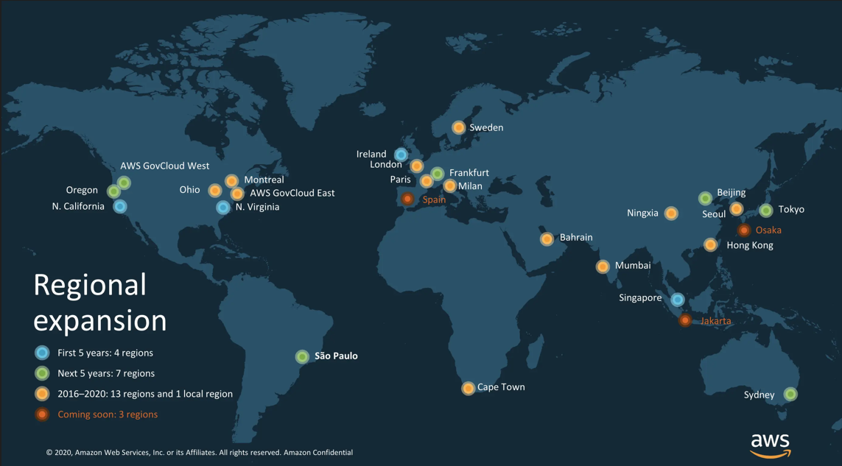

**Key Features:**

* **Geographic Distribution**: Regions are spread across the globe, allowing you to choose the location that best suits your needs. This is crucial for factors like latency (data transfer speed) and data residency regulations.
* **Isolated Regions**: Each Region operates independently with its own infrastructure. This ensures an outage in one Region won't affect another, enhancing overall reliability.
* **Collection of AZs**: A Region groups several Availability Zones, providing you with geographically separate locations to deploy your resources for high availability.

**AWS Data Centers:**

AWS data centers are the physical facilities that house the servers, storage systems, and networking equipment that power the AWS cloud. They are the backbone of the entire AWS operation, providing the physical infrastructure for all the services you use.

**Global Network:**

AWS has a vast network of data centers spread across multiple Regions around the world. This ensures geographically distributed infrastructure for redundancy and fault tolerance.

**Security-First Approach:**

Security is paramount for AWS data centers. They employ a layered security approach that includes physical security measures like restricted access, surveillance, and advanced security protocols to safeguard your data.

**Optimized Environment:**

Data centers are meticulously designed to maintain optimal temperature and humidity for efficient equipment operation. Redundant power supplies and climate control systems ensure smooth operation even during emergencies.

**Focus on Scalability:**

AWS data centers are built with scalability in mind. They can be expanded rapidly to accommodate the ever-growing demand for cloud services.

Overall, AWS data centers provide a secure and reliable foundation for the vast array of cloud services offered by AWS. They are constantly evolving to meet the ever-increasing demands of cloud computing.

**Availability Zones:**

An Availability Zone (AZ) is a fundamental building block of an AWS Region. Imagine a large geographic area, like a country or continent. This is an AWS Region.

Within each region, AWS maintains multiple isolated data centers, spread geographically. These are the Availability Zones.

**Key Features:**

* Isolation: Each AZ has independent power, cooling, and networking. This means an outage in one AZ shouldn't affect the others, promoting high availability.
* Redundancy: Everything within an AZ is redundant, meaning there are backups in case of hardware failure.
* Low Latency: AZs are connected with high-bandwidth, low-latency links for efficient communication between resources across zones.

**Benefits:**

* High Availability: By deploying your resources (like virtual machines) across multiple AZs, you ensure they remain available even if one AZ experiences an outage.
* Fault Tolerance: Redundancy within each AZ minimizes downtime caused by hardware failures.
* Scalability: You can easily scale your resources by adding instances in different AZs within the same region.